To Create a Private Amazon S3 Bucket

Objectives

After completing this lab, you will know how to:

Create a bucket in Amazon S3

Add an object to a bucket

Manage access permissions on an object and a bucket

Create a bucket policy

Use bucket versioning

Step 1: Navigate to Amazon S3
Log in to your AWS Management Console and navigate to the Amazon S3 service.
- In the search bar, type S3 and select Amazon S3 from the results.
- You will land on the S3 home page. Click Create bucket to begin.
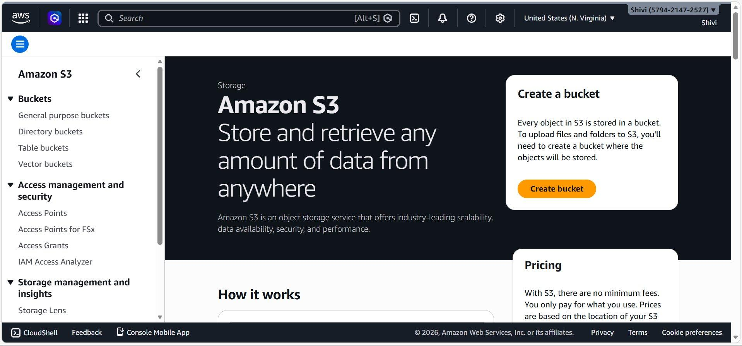

Step 2: Configure Bucket Type and Name
On the Create bucket page, configure the following settings:
- Bucket type: Select General purpose (recommended for most use cases).
- Bucket namespace: Choose Global namespace (default) or Account Regional namespace.
- Bucket name: Enter a unique name .Names must be 3-63 characters, lowercase, with letters, numbers, hyphens, or periods.
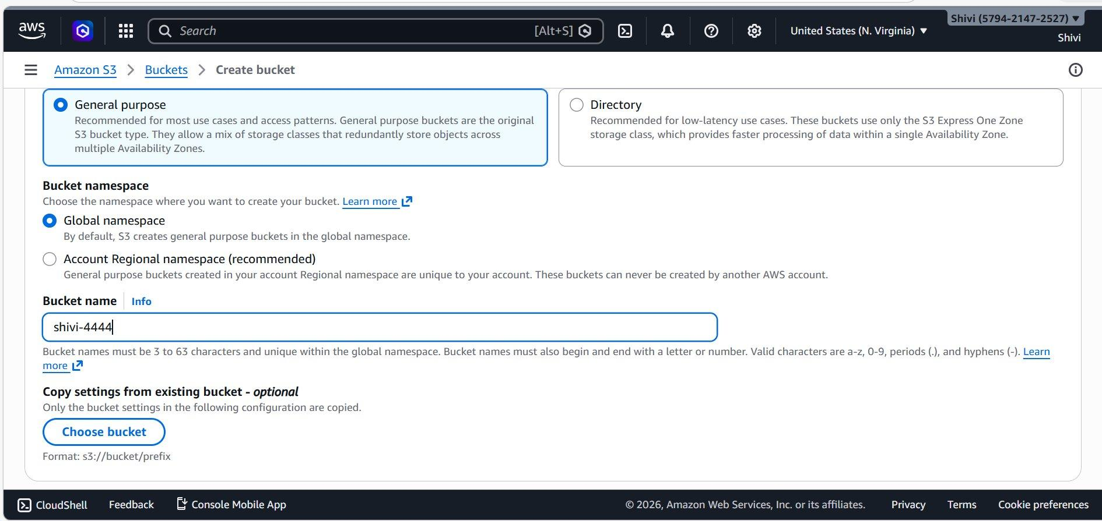

Step 3: Set Object Ownership
Scroll down to the Object Ownership section. Select ACLs disabled (recommended). All objects are owned by your AWS 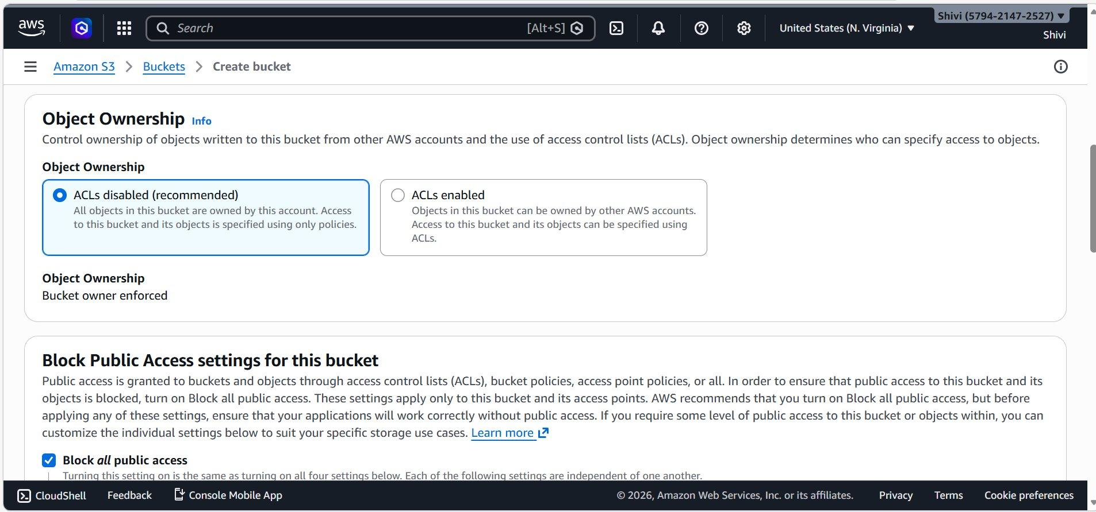

Step 4: Block All Public Access
This is the critical step to ensure the bucket remains private:
- Check the box for Block all public access.
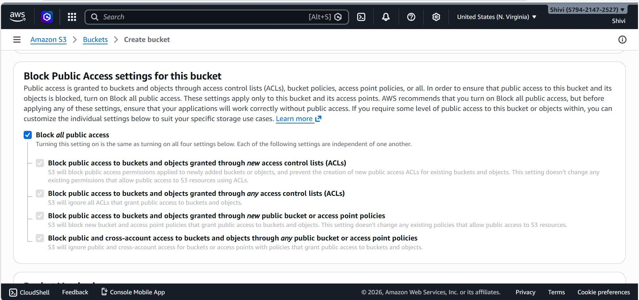

Step 5: Configure Default Encryption
Scroll to the Default encryption section:
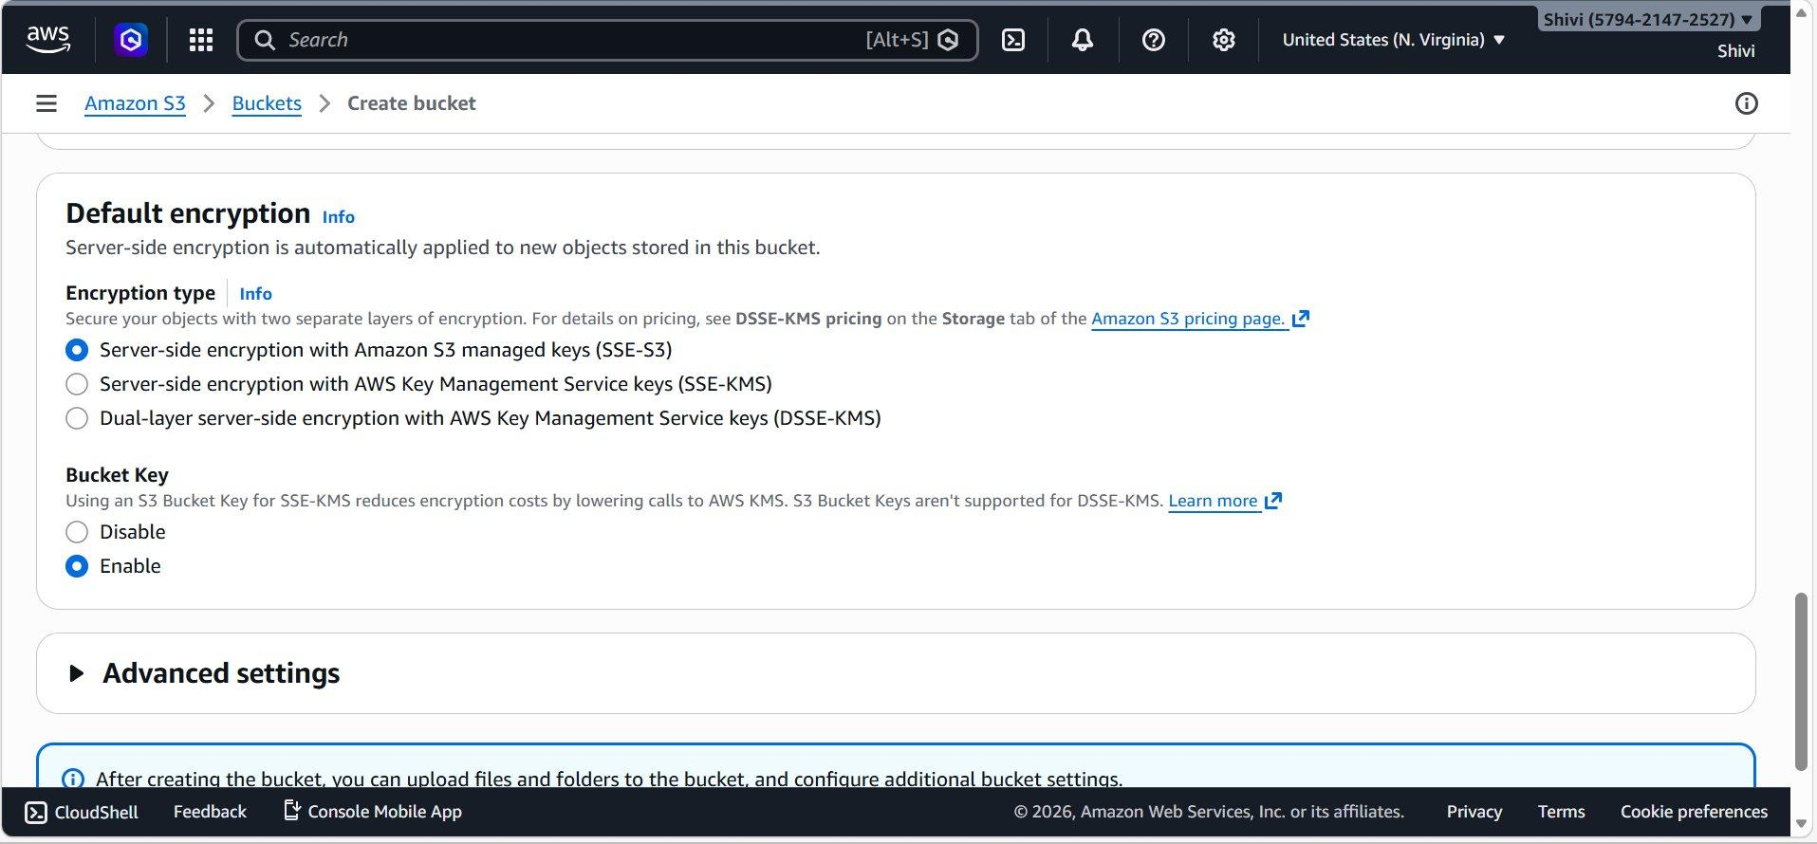

Step 6: Upload a File to the Bucket
After the bucket is created, upload your files:
- Navigate into your bucket (e.g., shivi-4444) and click Upload.
- Drag and drop files, or click Add files / Add folder to browse.
- Selected files (e.g., OIP.jpg) will appear in the Files and folders list.
- Confirm the Destination bucket and click Upload.
.
